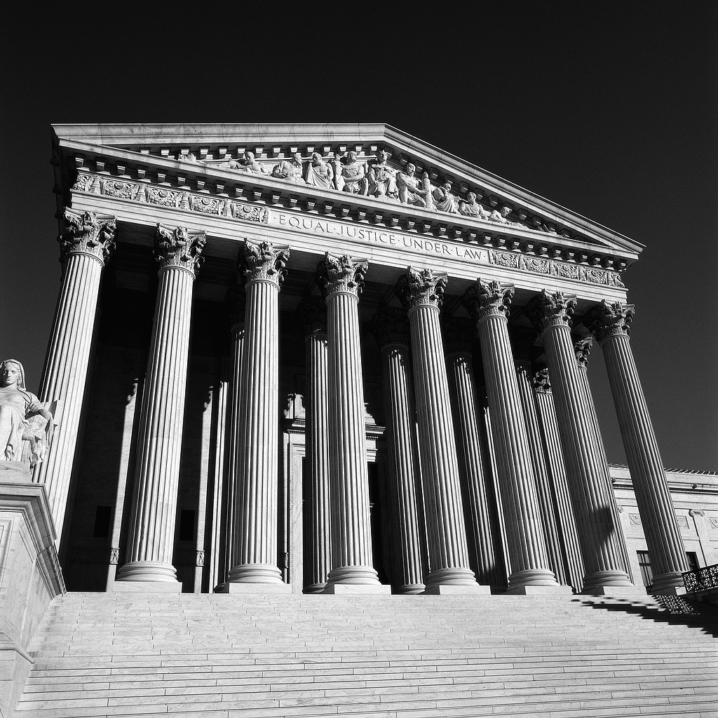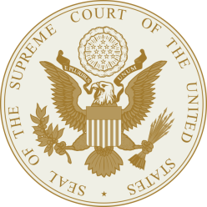

**Supreme Court Case PowerPoint Project**

The Supreme Court is the highest court in the nation, and therefore is the primary overseer of the judicial branch of the government. The Supreme Court’s responsibilities are relatively straight forward, with its most significant being judicial review. This process gives the Supreme Court the power to determine whether existing laws are unconstitutional. The Supreme Court has had an immeasurable impact on the American political system by helping to maintain fairness and balance in the U.S. government. They have overseen hundreds of national court cases, many of which have resulted in decisions that have in some way affected virtually every member of society.

**PowerPoint Requirements:**Use as little text as possible. Tell an oral story using images. Use text only when necessary.  
**Time Requirement: Max 5 minutes**

**Slide 1**- Case Name, Citation, date, your name

**Slide 2** – Background story- What was going on at the time, issues of the time

**Slide 3-** Who is the Petitioner, and Respondent – their background

**Slide 4 –**What are the issues at hand? What amendment is violated, which law has been broken

**Slide 5-** Judicial process- how did it get to the Supreme Court?

**Slide 6 –**Reasons why the case was allowed to be heard

**Slide 7-**Vote of the court – which judges voted for, and against.

**Slide 8**-Majority opinion – A quote –what does it mean, who said it

**Slide 9-**Dissenting Opinion –A quote, what’s the meaning, and who said it?

**Slide 10-**What precedents came before and what was their significance

**Slide 11-** What is the significance of this case in our lives today?