Economic Systems
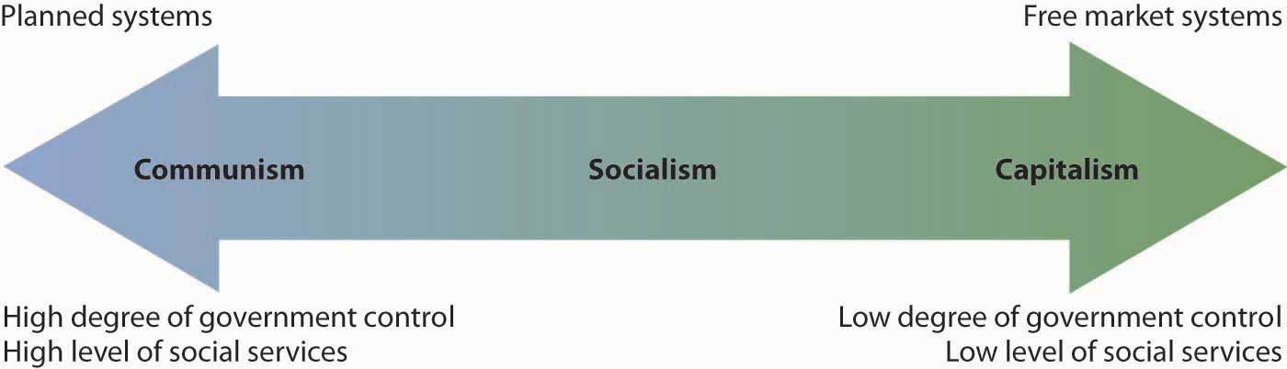
Def. The m___________ used by a society to p_______________ and distribute goods and s__________.
Or, How the g________________________ tells us what we can get and h_______ to get it!
All Economic Systems Must Consider the Following Questions:
- W______ goods and services to produce?
- H______ will they produce them?
- W____ will get them?
- H____ much will they produce now, and how much later?
Each economic system answers these questions in a D______________ WAY.
There are____ basic types of economic s________.
- T__________________ Economy
- Economic questions are answered by habits and c____________ (the way it has always been done)
- C______________ work the same jobs parents worked, often f_________ or hunter/gatherer
- Fear C___________!
- Ex. E________, the A__________
- C___________________ Economy (centralized)
- The g__________________ answers the basic economic questions
- A_____________________: able to act quickly in emergencies, provide for all people e_______
- D___________________: Inefficient, no i_______________ to work hard or be c__________
- Ex. Communist Countries (C_______________, Vietnam, North K______________, former
Soviet Union, Cuba)
- Free M______________ Economy (Decentralized)
- Economic questions are answered by individual b_________ and s______________.
- S______________ and d______________ influence economy
- People act out of self i________________; motive for profit (m___________) drives the economy
- Also known as FREE ENTERPRISE or C____________________
- Ex. The United States, Western Europe, Japan
- M_________________ Economy: No economy is pure market, pure command or pure traditional, elements of each appear in all economies, some have more elements of one economy than another.

American Mixed Economy
While the United States is mostly a free market economy, it does have elements of a c____________ economy.
Features of American Free Market Economy
- Economic F__________________: individuals have the right to c________________
- C____________________: more than one p______________ of good/services insures choice
- P______________ Property: individuals have the r__________ to own their own property, including
b__________________
- Self-I_____________: individuals make decisions based on what is b_____ for them
- V___________Exchange: individuals may f_________ buy and sell goods
- P__________Motive: individuals are driven by a desire to profit (make m____________)
Features of American Command Economy
- Government r_________________ of some business practices
Ex. W____________, labor hours, s___________ practice.
- Government l___________ certain choices
Ex. C______________ buy or produce certain goods/services (weapons of mass destruction)
- Government provides aid to the n_________
Ex. Medicare, Medicaid, w____________
How would my pizzeria function under different economic systems?
_____________________________________________________________________________________________________________________________________________________________________________________________________________________________________________________________________________________________________________________________________________________________________________________________________________________________________________________________________________________________

