MALALA YOUSAFZAI
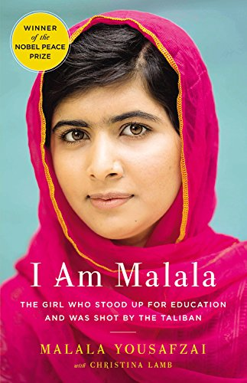
Quotes by Malala Yousafzai
“I speak not for myself but for those without voice... those who have fought for their rights... their right to live in peace, their right to be treated with dignity, their right to equality of opportunity, their right to be educated.”

“In some parts of the world, students are going to school every day. It's their normal life. But in other part of the world, we are starving for education... it's like a precious gift. It's like a diamond.”

“There are many problems, but I think there is a solution to all these problems; it's just one, and it's education.”

Malala Yousafzai was born on July 12, 1997, in Mingora, Pakistan. As a child, she became an advocate for girls' education, which resulted in the Taliban issuing a death threat against her. On October 9, 2012, a gunman shot Malala when she was traveling home from school. She survived, and has continued to speak out on the importance of education. She was nominated for a Nobel Peace Prize in 2013. In 2014, she was nominated again and won, becoming the youngest person to receive the Nobel Peace Prize.

EDWARD SNOWDEN
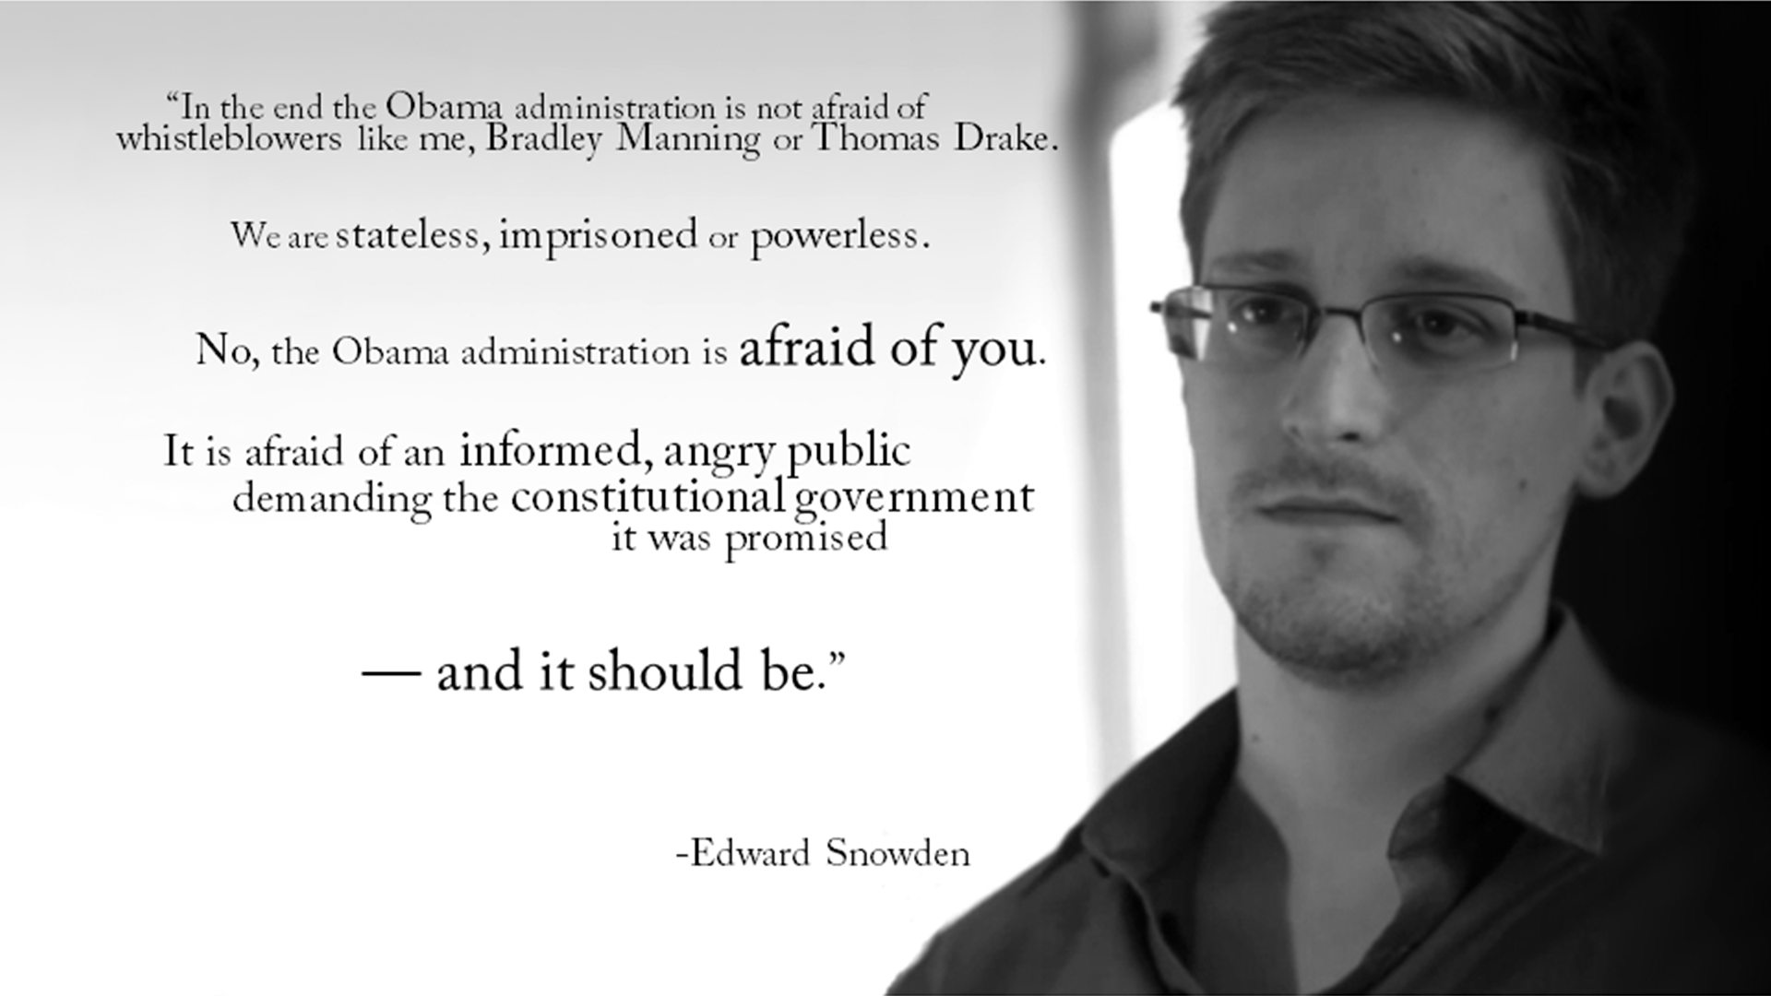
“I can't in good conscience allow the U.S. government to destroy privacy, internet freedom and basic liberties for people around the world with this massive surveillance machine they're secretly building.”

Born in North Carolina in 1983, Edward Snowden later worked for the National Security Agency through subcontractor Booz Allen in the organization's Oahu office. During his time there, Snowden collected top-secret documents regarding NSA domestic surveillance practices that he found disturbing. After Snowden fled to Hong Kong, China and met with Guardian journalists, newspapers began printing the documents that he had leaked, many of them detailing the monitoring of American citizens. The U.S. has charged Snowden with violations of the Espionage Act while many groups call him a hero. Snowden has found asylum in Russia and continues to speak about his work. A documentary on his story, Citzenfour, won an Oscar in 2015, with a 2016 biopic also in the pipeline.
CHELSEA MANNING
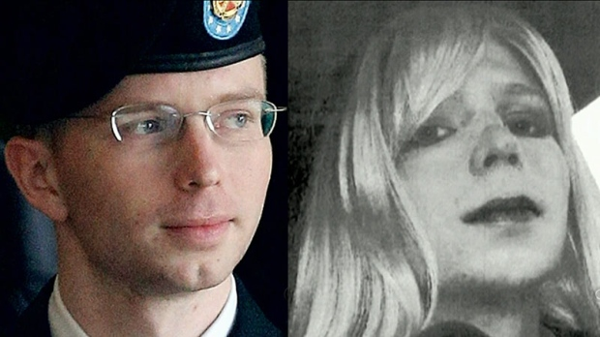
“I want people to see the truth... regardless of who they are... because without information, you cannot make informed decisions as a public.”
“I am Chelsea Manning. I am a female. Given the way that I feel, and have felt since childhood, I want to begin hormone therapy as soon as possible. I hope that you will support me in this transition.”
“I regret if my actions hurt anyone or harmed the United States. It was never my intent to hurt anyone. When I chose to disclose classified information, I did so out of a love for my country and a sense of duty to others.”
The soldier (born in 1987) accused of leaking Afghanistan documents to Wikileaks
Private First Class Bradley Manning -- now Chelsea Manning -- is the United States Army soldier accused in 2010 and convicted in 2013 of exposing secret government documents concerning the U.S. military campaigns in Iraq and Afghanistan. Manning enlisted in the Army in 2007, after growing up in central Oklahoma and Wales (her mother's home). Her name first surfaced in late 2009, as the source of "Collateral Murder," a video released by Wikileaks, a online organization that specializes in publishing classified documents. The video, from 2007, shows U.S. forces firing on civilians in New Baghdad. The video was newsworthy because two victims on the ground ended up being employees of Reuters, a news gathering organization. The rest of her story is unclear. It seems that Manning, at some point in early 2010, communicated to semi-famous (and convicted) computer hacker Adrian Lamo that she had spirited away more than 250,000 classified documents as an intelligence analyst for the Army. Lamo reported this to federal agents and Wired magazine, and Manning -- who'd been in custody since May -- was officially charged in early July of leaking at least 90,000 of those classified documents to Wikileaks. The word from Wikileaks was they didn't know who sent them the documents (but they aided in the defense of Manning). The word from the U.S. military was that Manning's leak was a serious breach that endangered those in the battlefield, as well as the nation's standing abroad. The word from Manning's supporters was that she is an American hero for blowing the whistle on corrupt and immoral practices within the U.S. government. She was convicted on 20 counts and sentenced in August of 2013 to 35 years in prison. (After Manning's sentencing, she announced her intention to undergo hormone therapy and to live as a woman, identifying as Chelsea Manning.)
DR. MARTIN LUTHER KING JR
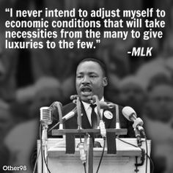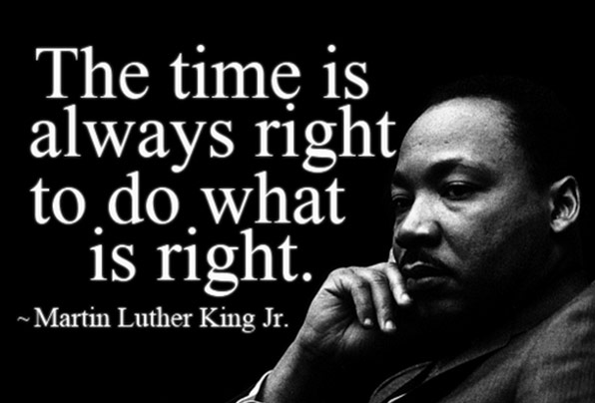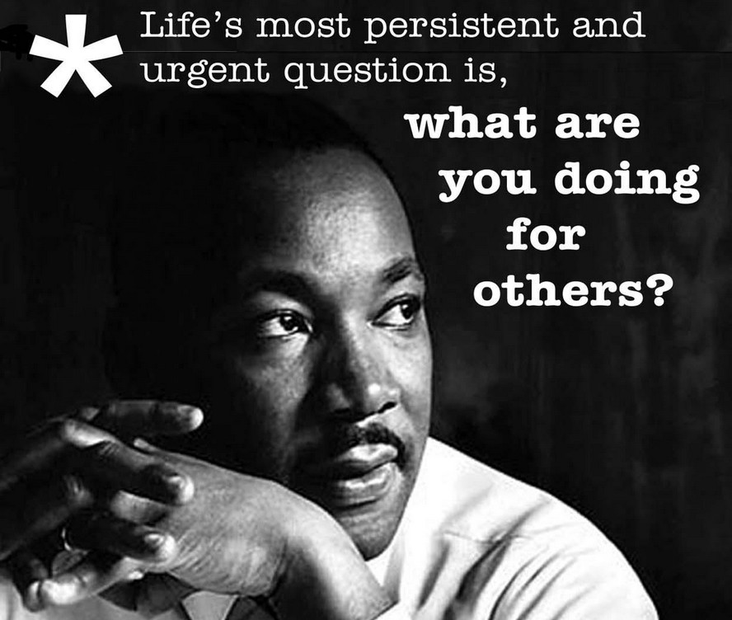
Martin Luther King Jr. was born on January 15, 1929, in Atlanta, Georgia. King, both a Baptist minister and civil-rights activist, had a seismic impact on race relations in the United States, beginning in the mid-1950s. Among many efforts, King headed the (Southern Christian Leadership Conference) SCLC. Through his activism, he played a pivotal role in ending the legal segregation of African-American citizens in the South and other areas of the nation, as well as the creation of the Civil Rights Act of 1964 and the Voting Rights Act of 1965. King received the Nobel Peace Prize in 1964, among several other honors. King was assassinated in April 1968, and continues to be remembered as one of the most lauded African-American leaders in history, often referenced by his 1963 speech, "I Have a Dream."
MALCOLM X
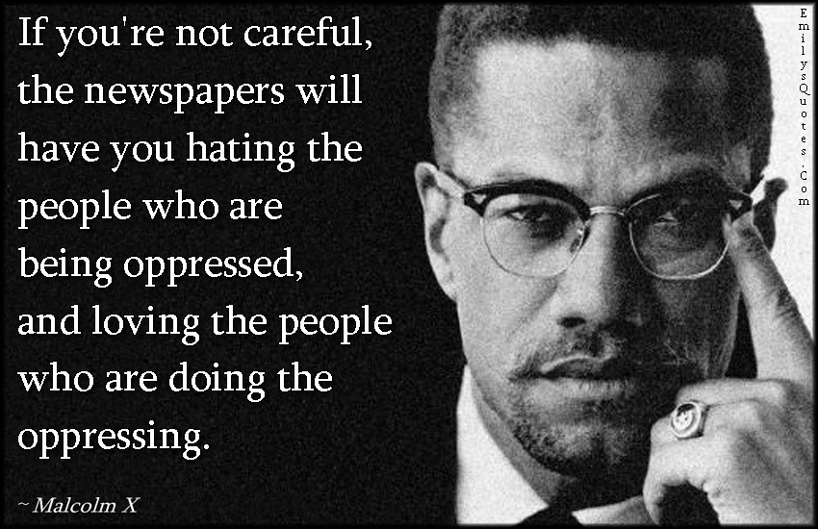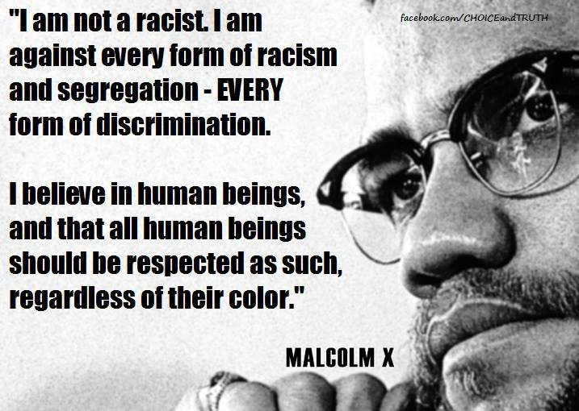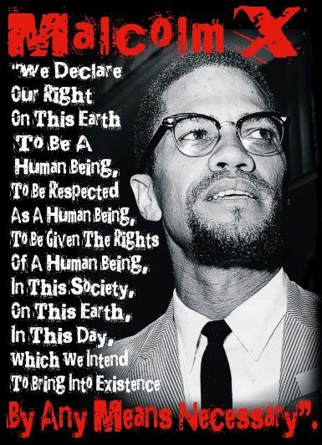
Malcolm X was born Malcolm Little on May 19, 1925, in Omaha, Nebraska. His father, a Baptist minister, was an outspoken follower of Marcus Garvey (1887–1940), the black nationalist leader. (A nationalist is a person who promotes one nation's culture and interests over all others.) Garvey supported a "back-to-Africa" movement for African Americans. During Malcolm's early years, his family moved several times because of racism (dislike and poor treatment of people based on their race). They moved from Omaha, Nebraska, after being threatened by the Ku Klux Klan, a group that believes that white people are superior to all other races. While living in an all-white neighborhood in Michigan their house was burned. When Malcolm was six years old, his father was mysteriously murdered. The black community was convinced that white people had committed the crime. Three of Malcolm's four uncles were also murdered by white people.
Malcolm X was a prominent black nationalist leader who served as a spokesman for the Nation of Islam during the 1950s and '60s. Due largely to his efforts, the Nation of Islam grew from a mere 400 members at the time he was released from prison in 1952 to 40,000 members by 1960. Articulate, passionate and a naturally gifted and inspirational orator, Malcolm X exhorted blacks to cast off the shackles of racism "by any means necessary," including violence. The fiery civil rights leader broke with the group shortly before his assassination, February 21, 1965, at the Audubon Ballroom in Manhattan, where he had been preparing to deliver a speech.
BERTA CACERES
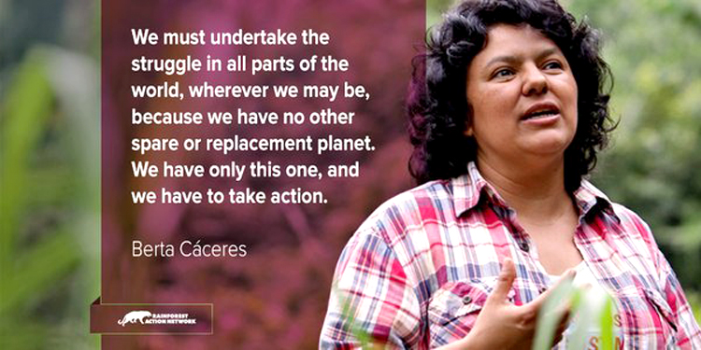
Berta Cáceres (Berta Isabel Cáceres Flores), (born March 4, 1973?, La Esperanza, Hond.—died March 3, 2016, La Esperanza) Honduran activist who cofounded (1993) the National Council of Popular and Indigenous Organizations of Honduras (COPINH) and devoted 10 years to a campaign to stop the construction of the Agua Zarca Dam on the Gualcarque River in the Rio Blanco area of Honduras, work for which she was awarded a 2015 Goldman Environmental Prize. Cáceres, a member of the indigenous Lenca people, was the daughter of a midwife and social activist. She helped establish COPINH to help Lenca communities resist illegal logging and other such threats to homes and societies. In 2006 people of the Rio Blanco area asked COPINH for help, as dam construction had begun without the legally required notice on a river that was economically and spiritually important for the populace around it. Cáceres responded by filing complaints with government authorities and with the Inter-American Commission on Human Rights and by appealing to businesses that were funding the dam to withdraw support. Those efforts proved unsuccessful, however, and in 2013 Cáceres organized a human blockade of the road to access the construction site. The blockade stayed in place for more than a year, and protests continued to take place thereafter. Criminal charges were filed against Cáceres, and she and other activists were routinely threatened with kidnap and murder. After one protest leader was killed in 2013, Sinohydro, the Chinese partner of the Honduran company building the Agua Zarca Dam, withdrew from the project, and the International Finance Corporation later withdrew its support. Cáceres was murdered in her home.
RIGOBERTA MENCHU
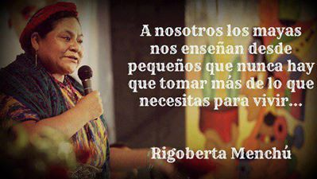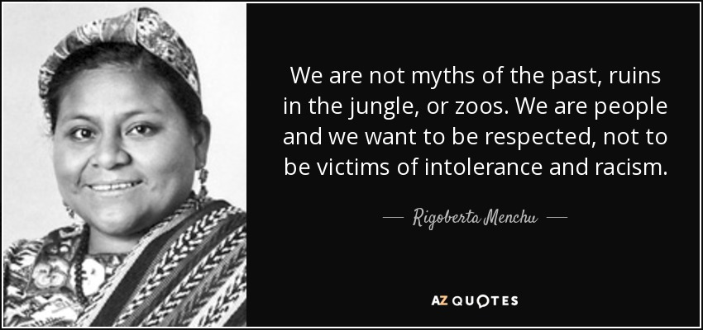

Rigoberta Menchu is a Guatemalan activist who has worked for the rights of the Mayan people in her country her entire life. She has experienced extreme adversity since she was young, including losing many members of her family to the cruelty of the Guatemalan government. She got involved in social activism very early in her life and followed her parents' footsteps in opposing the Guatemalan government during the country's civil war. After organizing protests and movements against the Guatemalan government in the early 1980s, she was forced into exile in Mexico for fear of losing her life. She continued working for the freedom of the Mayan people and was awarded the Nobel Peace Prize for her work. She has unceasingly sought retribution for the oppressed Mayan people and gained ground towards that goal including helping drive the Guatemalan Civil War to its end, development of peaceful political parties in Guatemala and prosecution of the Guatemalan officials who committed genocide against her people. Her life has been chronicled in two books and a documentary and she stands as a symbol for the fight against oppression against ethnic and poor classes.

