Law of supply

Key points
- The law of supply states that a higher price leads to a higher quantity supplied and a lower price leads to a lower quantity supplied.
- Supply curves and supply schedules are tools used to summarize the relationship between supply and price.

Supply of goods and services
When economists talk about supply, they mean the amount of some good or service a producer is willing to supply at each price. Price is what the producer receives for selling one unit of a good or service. A rise in price almost always leads to an increase in the quantity supplied of that good or service, while a fall in price will decrease the quantity supplied. When the price of gasoline rises, for example, it encourages profit-seeking firms to take several actions: expand exploration for oil reserves; drill for more oil; invest in more pipelines and oil tankers to bring the oil to plants where it can be refined into gasoline; build new oil refineries; purchase additional pipelines and trucks to ship the gasoline to gas stations; and open more gas stations or keep existing gas stations open longer hours. Economists call this positive relationship between price and quantity supplied—that a higher price leads to a higher quantity supplied and a lower price leads to a lower quantity supplied—the law of supply. The law of supply assumes that all other variables that affect supply are held constant.

Supply schedule and supply curve
- A supply schedule is a table that shows the quantity supplied at each price.
- A supply curve is a graph that shows the quantity supplied at each price.
Here's an example of a supply schedule from the market for gasoline.
Price (per gallon) | Quantity Supplied (millions of gallons)
$1.00 | 500
$1.20 | 550
$1.40 | 600
$1.60 | 640
$1.80 | 680
$2.00 | 700
$2.20 | 720

Price is measured in dollars per gallon of gasoline and quantity supplied is measured in millions of gallons.
Here's the same information shown as a supply curve with quantity on the horizontal axis and the price per gallon on the vertical axis. Note that this is an exception to the normal rule in mathematics that the independent variable goes on the horizontal axis and the dependent variable goes on the vertical.
A supply curve for gasoline
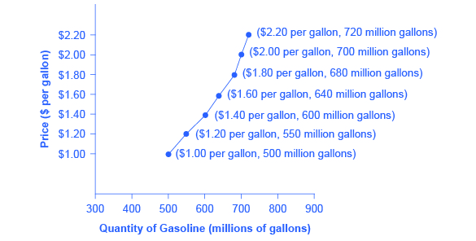
The graph shows an upward-sloping supply curve that represents the law of supply.
The supply curve is created by graphing the points from the supply schedule and then connecting them. The upward slope of the supply curve illustrates the law of supply — that a higher price leads to a higher quantity supplied, and vice versa.
The shape of supply curves will vary somewhat according to the product: steeper, flatter, straighter, or more curved. Nearly all supply curves, however, share a basic similarity: they slope up from left to right and illustrate the law of supply: as the price rises, say, from \$1.00$1.00dollar sign, 1, point, 00 per gallon to \$2.20$2.20dollar sign, 2, point, 20 per gallon, the quantity supplied increases from 500500500 gallons to 720720720 gallons. Conversely, as the price falls, the quantity supplied decreases.

The difference between supply and quantity supplied
In economic terminology, supply is not the same as quantity supplied. When economists refer to supply, they mean the relationship between a range of prices and the quantities supplied at those prices, a relationship that can be illustrated with a supply curve or a supply schedule. When economists refer to quantity supplied, they mean only a certain point on the supply curve, or one quantity on the supply schedule. In short, supply refers to the curve and quantity supplied refers to a specific point on the curve.

