Next Test for Guatemala’s Protest Movement: Improving Citizens’ Lives
By ELISABETH MALKINSEPT. 15, 2015
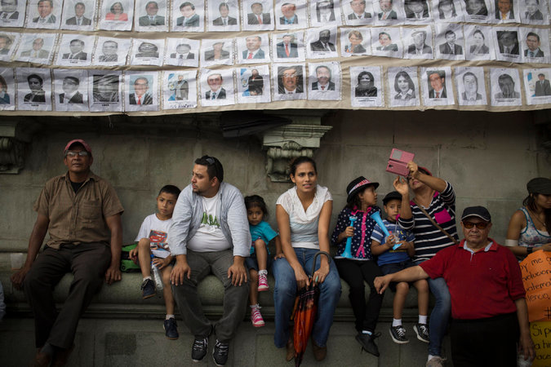
Protesters under a banner of lawmakers' portraits outside the National Palace in Guatemala City on Aug. 27 during a national strike calling for new congressional elections as well as the resignation of President Otto Pérez Molina.CreditLuis Soto/Associated Press
Advertisement
GUATEMALA CITY — Shortly after 5 a.m. one day last week, a security guard opened the entrance of Roosevelt Hospital here to patients who had been lining up in the dark mountain chill for more than an hour.
With silent purpose, they pushed through battered, half-lit hallways to claim the first places on wooden benches outside doors marked with words that promised help: urology or neurosurgery. Some had traveled for as many as eight hours to get here, guarding slips of paper from doctors who had sent their patients across the country to the best specialty hospital Guatemala’s public health system can offer.
“We were a people that never complained,” said Dr. Arnoldo López, a pediatric surgeon at the hospital, as he described the doctors’ battles to get the budgets they needed. “The patients think the attention they receive is normal.”
But in a few stunning months, Guatemalans shook off that resignation.
In response to a widening corruption scandal, a mass protest movementforced out the president, Otto Pérez Molina, less than two weeks ago.
Photo
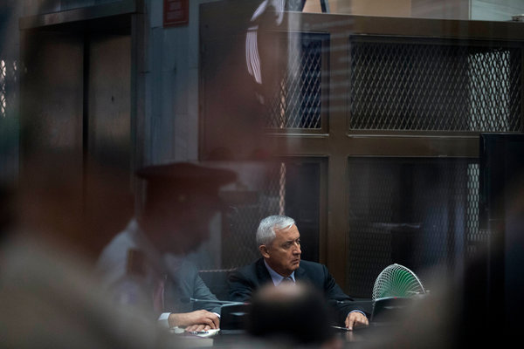
Former President Otto Pérez Molina of Guatemala at a court hearing last week on the fraud and bribery charges that led him to resign almost a week earlier. CreditEsteban Felix/Associated Press
Days later, as Mr. Pérez Molina went to jail to await trial on fraud and bribery charges, Guatemalans rejected the corruption-tainted front-runner in the elections to replace him, diluting the power of traditional parties.
Jimmy Morales, a comedian with no political experience, won the first round of voting, campaigning under the slogan, “Not corrupt, not a thief.”
The real test now is whether that new boldness and optimism will result in a tangible difference in Guatemalans’ lives. Will it give doctors at Roosevelt Hospital the resources to do the simple things they cannot do now — like sending a patient downstairs for an X-ray or giving out medicine?
“It would be a good time to ask for a better budget,” Dr. López said. “There should be greater social pressure to demand better health care.”
Underlying the political upheaval is Guatemala’s vast gulf between rich and poor, a legacy born of the Spanish conquest that has evolved into a thicket of favors and corruption among politicians, the military and the privileged business class.
That system has drained public resources — Mr. Pérez Molina has been accused of being a ringleader in a plan to siphon off millions of dollars in customs revenue — and fostered powerful monopolies, from television to medicine distribution.
The question, as citizens push for more changes, is how much the business and political elite will yield.
“We want to create hope,” said Andrés Quezada, 23, one of the organizers of the first protest march in April. “The future is uncertain.”
Mr. Quezada and a small group of friends started the movement when they sent out an invitation to march in this city’s central square and unexpectedly got 10,000 confirmations in a day. Now their Facebook page,Justicia Ya, or Justice Now, has become a clearinghouse for discussions about the movement’s future. Its hashtag is a challenge, both to the society’s power brokers and to the activists: “This is just getting started.”
Guatemala has the biggest economy in Central America, according to the World Bank, but a raft of statistics illustrates its stubborn inequalities. One is particularly shocking: Almost 50 percent of Guatemalan children suffer from chronic malnutrition, one of the highest rates in the world.
“You can only explain that when you have a state that doesn’t work,” said Frank La Rue, a longtime human rights activist in Guatemala and a former United Nations official. “You have 60 percent of the population in poverty, and it affects an entire nation.”
The World Bank explains why: Guatemala collects the lowest taxes in the world and spends the least on health, education and infrastructure as a proportion of its economy.
“Five or 6 percent of the population leads this country in every aspect,” said Valerie Julliand, the representative for the United Nations Development Program in Guatemala, referring to the mostly white urban elite. But, she added, “the real face of this country are those of young indigenous women.”
To hear the powerful business community tell it — new rich and old — the solutions to Guatemala’s problems would fall into place if corruption were removed and tax evasion were curbed.
Photo
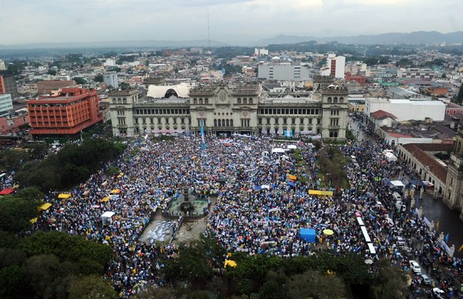
A protest in May in Guatemala City was aimed at ousting President Otto Pérez Molina.CreditJohan Ordonez/Agence France-Presse — Getty Images
“All this would change if the money went to society,” said Mario López Estrada, Guatemala’s first Forbes billionaire, in an interview at his spacious glass-walled office. “But if it continues to be lost, it’s impossible.”
In the glow of early optimism, Mr. López said he welcomed the nation’s transformation. “I think that businesses should support the social movements that emerge from the nation’s soul,” he said. “If we have to correct something as businessmen, then we have to correct it.”
Mr. López is the minority owner of the country’s largest telecommunications company, Comcel, which is known under the brand name Tigo. He was half-serious when he joked that Tigo’s drive to switch Guatemalans to smartphones made the street movement possible, and he seemed to think that the new push toward greater accountability would continue.
“From now on, the political leaders and their teams will face permanent social scrutiny over their actions,” Mr. López said.
Social media is “the new actor in the country’s political life,” he continued. “I don’t want to say it, but in a certain way the populace is in debt to us.”
Over at the Foundation for the Development of Guatemala, or Fundesa, a research group affiliated with the business chamber Cacif that unites many of the old monopolies, the distaste for politicians is shared.
“Guatemala’s biggest problem is corruption; there is no problem of resources,” said Fundesa’s executive director, Juan Carlos Zapata. “We believe that 30 percent of the budget is lost to corruption.”
Mr. Pérez Molina was an ally of businesses, and the scheme in which he has been implicated involved taking bribes from importers in exchange for lowering their customs duties.
But as the bribery scandal turned Guatemala’s electoral politics upside down and other candidates were tarred by corruption allegations, business owners swung behind Mr. Morales, the television comedian. He started his campaign with the backing of right-wing military veterans of the country’s long-running civil war.
Mr. Morales rode his outsider status to win the first round and will face Sandra Torres, a leftist former first lady known for her social programs, in an Oct. 25 runoff.
Reformers are eager to further the momentum for change. The interim president, Alejandro Maldonado, a conservative judge, has promised overhauls. Civic groups suggest that the place to start is the 2016 budget — particularly its spending on health.
But the results seem far-off in the scuffed passages of Roosevelt Hospital, where people doze as they wait to see a specialist or wonder how they will pay for the medicine and X-ray the doctor might order.
Juan Pu Us, a farmer from the northwestern state of Quiché, has borrowed more than $1,300 since his 18-year-old daughter, María Elena, collapsed in December from a brain hemorrhage and he paid for an ambulance to drive her eight hours to the capital.
The story ended happily. The doctors at the hospital operated on her, and she returned last week with her parents for a checkup. Maybe that was why Mr. Pu Us was feeling hopeful about the future after the past few months’ turmoil — for both his family and the country.
“God willing, Guatemala will improve,” he said. “It’s good to protest. The leaders have to sort themselves out.”

